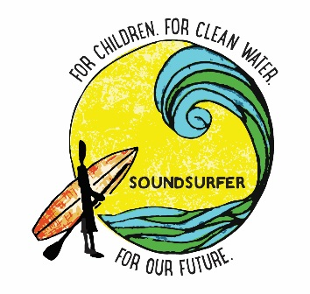

DIRECTIONS TO THE 2017 SOUNDSURFER WATERMAN’S CHALLENGE
The event is in Seaside Park (WEST BEACH), Bridgeport CT. There will be Signs posted along the road on the way in to help you. ENTER BARNUM BLVD, Bridgeport CT into your GPS and it should take you to the WEST GATE.

From the North (on 95)
- Exit 27 toward Lafayette Blvd/downtown
- Keep left at the fork towards exit 27A, 25/8/Trumbull
- Continue onto South Ave (you will pass SANTA FUEL on your right)
- Stay straight on South Ave and wrap around left onto Barnum Dyke
- Make a right onto Barnum Blvd
- GO through gate and continue to the beach where we are!

From the South (going on 95 north)
- Take Exit 26 (Wordin)
- Stay straight off the ramp, shifting to the right along the highway (Don't get back on the highway)
- Use right lane to Turn slightly left onto Pine Street
- Turn left onto Admiral St (Santa Fuel will be in front of you- pass it, keeping it on your right)
- Turn Right onto Iranistan Ave
- Make Right onto South Ave (essentially going around Santa Fuel)
- Stay straight on South Ave
- Continue on South ave and wrap around left onto Barnum Dyke
- Make a right onto Barnum Blvd
- GO through gate and continue to the beach where we are!

*There is a $20 per car fee at the gate. Cash only is accepted

